Lee County Public Service Authority
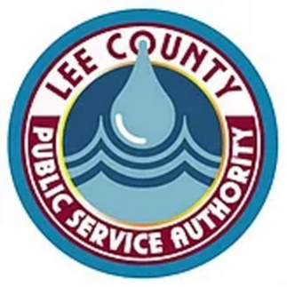
December 2, 2025
Board Meeting Minutes
- The Lee County Public Service Authority’s Board of Directors conducted their regular monthly board meeting on Tuesday, December 2, 2025, at the PSA office in Jonesville, Virginia.
- Chairman Bill Carter called the meeting to order at 3:00 p.m. following the invocation and the Pledge of Allegiance.
- Chairman Carter performed a roll call of board members and determined a quorum was present. Participating in the meeting were board members: Bill Carter, Roger Gates, Harold Jerrell, and Greg Rasnic. Others participating were LCPSA Director Tracy Puckett and LCPSA Assistant Director Mike Brindle. Robert Horton was unable to attend.
Agenda:
- Rasnic made the motion to approve the agenda as presented, which was seconded by Jerrell and approved unanimously.
Public Expression:
- There was no Public Expression.
Financial Report:
- Jerrell made a motion to accept the Financial Report as presented. Rasnic seconded the motion, and it passed unanimously.
Previous Meeting Minutes:
- Rasnic made a motion to approve the minutes from the previous meeting as presented. Jerrell seconded the motion, and it passed unanimously.

Director’s Report:
- The Director’s report provided a brief overview of PSA operations and projects, highlighting the following projects:
  - Phase III Hancock Co, TN/Lee Co, VA – The engineer received VDOT approval and continues to work on the stream permits and easements.
  - Dryden Sewer – Project engineer is continuing to work with DEQ and the contractor to get this project started. Puckett stated he is very pleased with the fact that this project is 100% principal forgiveness, with no load dollars involved.
  - Western Lee Sewer – The engineer is working with USACE on answering their questions concerning the final design package. Meanwhile, we continue working with the engineer, LENOWISCO, LMU and USACE on how to proceed with easements.
  - Maple Hill – Puckett stated he had received word that VDH is permitting the PSA to use some of the remaining project funds to install a backup generator at the pump station, a fence around the pump station, and a zone meter used to assist in accountability and leak detection. VDH has requested that the PSA de-obligate the remaining funds after the generator, fence, and meter has been installed.
  - Stone Creek RT 421 Extension – LENOWISCO will be funding an extension on Rt 421 in the amount of approximately $60,000.00 for an area near the 421 Market in the Stone Creek. This extension will serve an additional 3 to 5 connections. Boyd’s Construction will be assisting the PSA with a large portion of this extension.
- Rasnic made a motion to accept the Director’s Report as presented. Jerrell seconded the motion, and it passed unanimously.
Old Business:
- There was no Old Business.
New Business:
- Under New Business, the board voted to authorize Director Puckett to sign the necessary documentation to de-obligate the remaining funds from the Maple Hill Project at the request of VDH, the funding agency for the project. Jerrell made the motion, seconded by Rasnic and passing unanimously.
Closed Session:
- There was no closed session.
Adjourn:
- Jerrell made a motion to adjourn, seconded by Rasnic, and passing unanimously. The board’s next meeting will be Tuesday, January 27, 2026 at 3 p.m.

